

**Subject Teacher**

**Muhammad Owais Rehmani**

* + - **Name: Firza Ghori**
    - **Batch: 23**
    - **Roll No: 036**
    - **Subject: Programming Fundamental**
    - **Department: Artificial Intelligence**

**Submitted date: 16 - 12-2023**

**Question#01;**

**Write a python program that takes two integers as input and calculates the sum of their squares only if both numbers are old. If any of the numbers is even. Print a message that the calculation is not performed.**

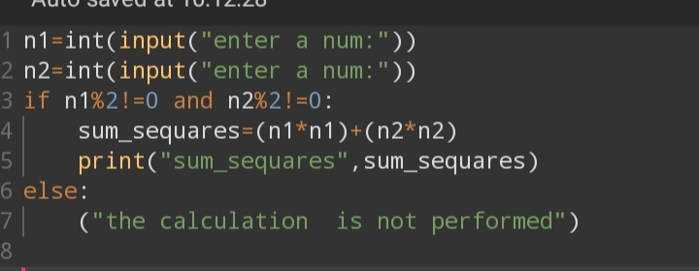

**Output:**

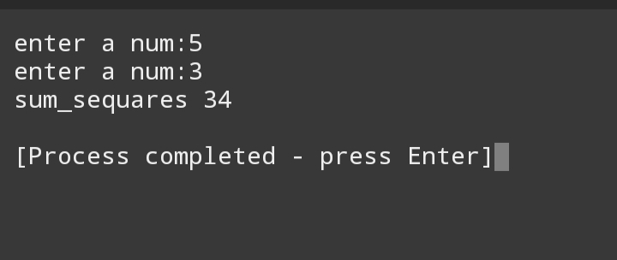

**Question#2**

**Write a python program to find and print factorial of a given number. Ensure the program includes a loop (either for or while) to calculate the factorial. Additionally, implement a condition to handle the case when the input number is negative. And print an appropriate message in such cases.**

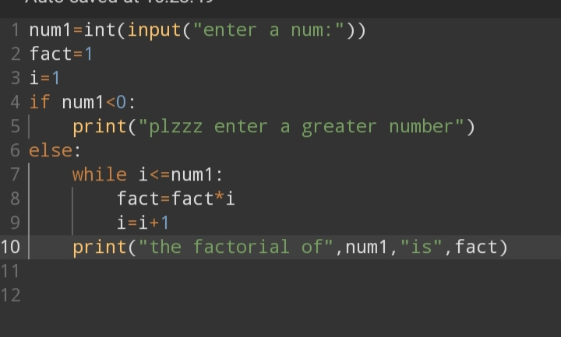

**Output:**

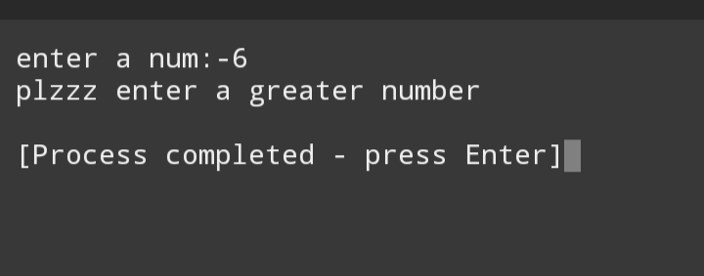

**Question#3:**

**Write a program that randomly generates a number between 1 and100. The user has to guess the number within 5 attempts. After each guess, provide feedback: “too high”, “too low”, or, “correct!”. If the user guesses correctly with in 5 attempts, print “congulation!” “You guessed the number.” Otherwise, print “game over! You ran out of this game.”**

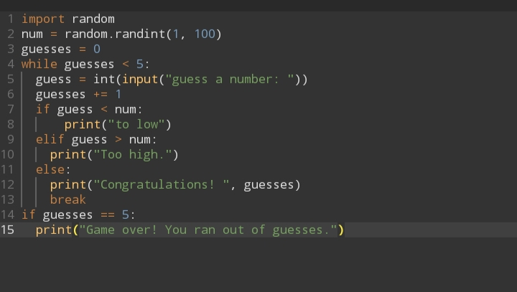

**Output**

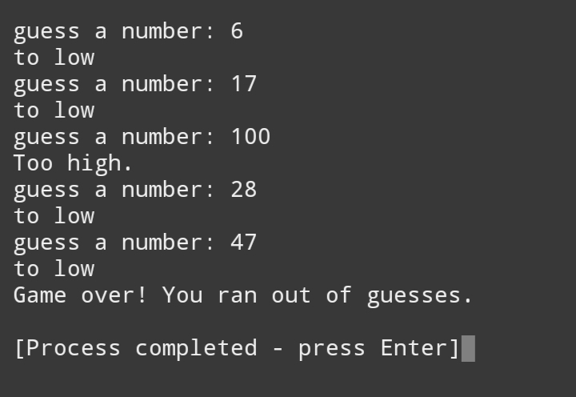

**Question# 4:**

**Write a program that asks the user for the following information about their restaurant bill:**

* **Number of people**
* **Cost of each meal**
* **Sales tax percentage**
* **Tip percentage**

**Based on the information provided, calculate and print the following:**

* **Total cost of food**
* **Total sale tax**
* **Total tip amount**
* **Total bill amount per person**

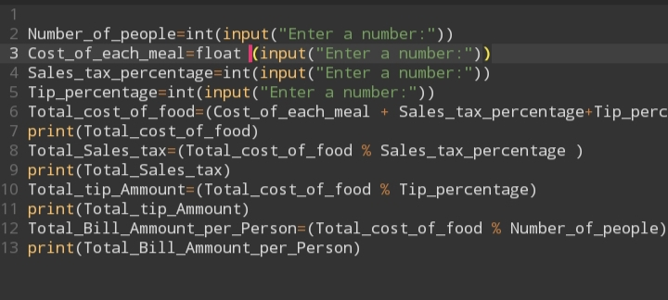

**Output:** 